Triple Rhyme Couplets

🎯 What is Triple Rhyme Couplets
# Source: AI Source: Provided by: [Data Path: Persons Table -> ID Column: 1, Name_En Column: Motasem Essam] -> From: [Chatgpt (GPT-4-turbo)] on [8/2/2025]
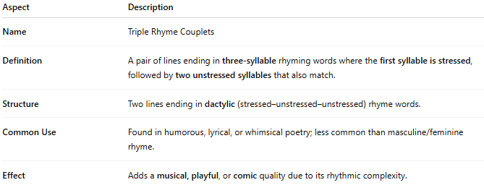
Aspect | Description
Name | Triple Rhyme Couplets
Definition | A pair of lines ending in three-syllable rhyming words where the first syllable is stressed, followed by two unstressed syllables that also match.
Structure | Two lines ending in dactylic (stressed–unstressed–unstressed) rhyme words.
Common Use | Found in humorous, lyrical, or whimsical poetry; less common than masculine/feminine rhyme.
Effect | Adds a musical, playful, or comic quality due to its rhythmic complexity.

✅ Example of Triple Rhyme in a Couplet
# Source: AI Source: Provided by: [Data Path: Persons Table -> ID Column: 1, Name_En Column: Motasem Essam] -> From: [Chatgpt (GPT-4-turbo)] on [8/2/2025]
He answered her so dutifully
She blushed and smiled beautifully
- "dutifully" / "beautifully" are triple rhymes:
  - Stressed on the first syllable: dú–ti–ful–ly, béau–ti–ful–ly
  - Followed by two matching unstressed syllables

🧠 Bonus:
# Source: AI Source: Provided by: [Data Path: Persons Table -> ID Column: 1, Name_En Column: Motasem Essam] -> From: [Chatgpt (GPT-4-turbo)] on [8/2/2025]
Triple rhymes are often considered a subset of feminine rhymes but with three syllables instead of two.

